CERTIFICATE OF DELIVERY

DATE | 01/05/2026
EQUIPMENT | CW tester 2 for 3600MHz NSW

PHOTO | ITEM | CANT
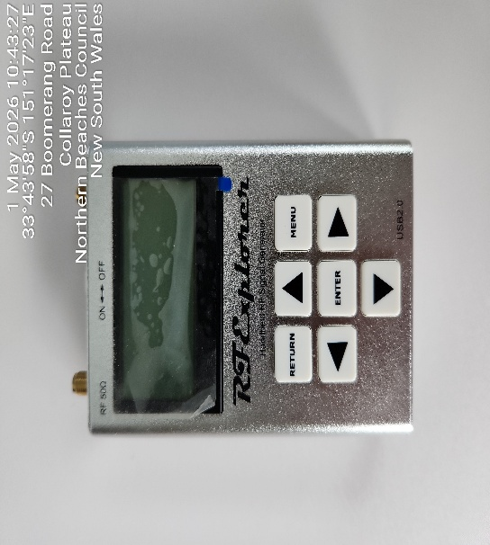 | RF Explorer Signal Generator  SN: B3EBD7L7E6B9AE3E | 1
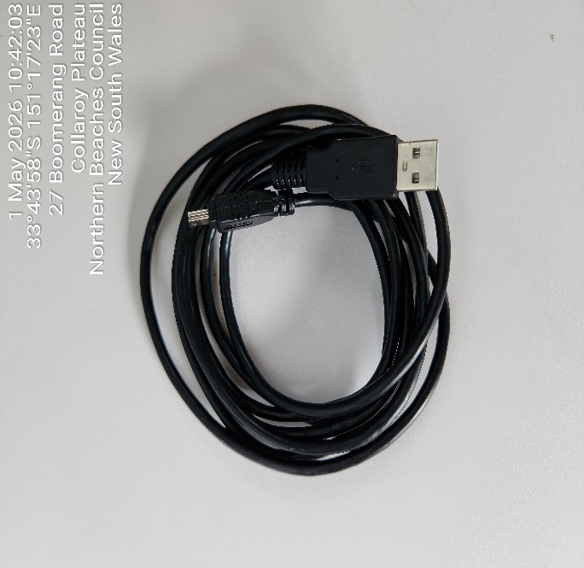 | Cable for Power Supply | 1

COMMENT:

